The lecture 3
Microsoft Intune is a cloud‐based management solution that allows you to manage your computers when they are connected to or not connected to the corporate network. In fact, you don’t even have to be part of your domain. Microsoft Intune helps you manage your computers and mobile devices through a web console. It provides the tools, reports, and licenses to ensure your computers are always current and protected. For mobile devices, it also allows you to manage your remote workforce by working through Exchange ActiveSync or directly through Microsoft Intune.
Microsoft Intune can be operated in cloud‐only mode or in a new unified configuration option that integrates the cloud‐based environment with Microsoft System Center 2012 Configuration Manager Service Pack 1 or System Center 2012 R2/2016 Configuration Manager. Microsoft Intune utilizes a subscription model in which you are charged on a per‐user basis.

Here are some of the things you can do with Microsoft Intune:
- Manage your mobile devices and computers through a web‐based console anywhere at
any time through Exchange ActiveSync and System Center 2012 R2/2016 Configuration Manager.
- Manage your Microsoft Intune subscription, add new users and security groups, set up and manage service settings, and access service status via a Microsoft Intune Account portal.
- Assess the overall health of devices across your organization using the Microsoft Intune Administration console.
- Organize users and devices into groups (geographically, by department, and by hardware characteristics).
- Manage updates for computers in your organization.
- Enhance security of your managed devices by providing real‐time protection, by keeping virus definitions current, and by automatically running scheduled scans.
- Access the overall health of your managed devices through the use of alerts.
- Deploy policies to secure data on mobile devices to determine which mobile devices can connect, enroll, rename, and un‐enroll devices.
- Wipe mobile devices in case they are stolen.
- Deploy software and detect and manage software installed on computers.
- Manage licenses purchased through Microsoft Volume Licensing agreements.
- Run reports on software, hardware, and software licenses to help confirm current needs and to plan for the future.
- Provide a cloud‐based, self‐service portal where users can enroll and manage their devices, search for and install software applications, and request help.

Microsoft Intune deploys a client agent on each device that you want to manage. The Microsoft Intune agent communicates back to the Microsoft Intune administration console, allowing you to inventory software and hardware assets in your organization.
Microsoft Intune can be deployed with the following configurations:
- Microsoft Intune Stand‐Alone Cloud Configuration: With this configuration, you have to administer your computers and devices (Windows 10, Windows 8/8.1, Windows RT, Windows Phone 8, Android, and Apple iOS) through the Administrator console. Although this configuration allows you to create and manage policies, inventory your devices, and upload and publish software, it does not support the discovery of mobile devices.
- Microsoft Intune Cloud + On‐Premise Configuration: This configuration integrates Microsoft Intune with your existing Active Directory and Exchange environment. With this configuration, you can discover mobile devices using Exchange ActiveSync, synchronize your user accounts with your Active Directory, and manage your mobile devices through Microsoft Intune.
- Microsoft Intune + System Center Configuration Manager: This configuration allows you to manage your computers and mobile devices from the System Center Configuration Manager 2012 R2/2016 console.

For the users to install Microsoft Intune client, they must have Internet connectivity and 200 MB available disk space. You can install the Microsoft Intune client on the following operating systems:
- Windows Vista Business, Enterprise and Ultimate
- Windows 7 Professional, Enterprise or Ultimate
- Windows 8/8.1 Pro or Enterprise
- Windows 10 Pro or Enterprise

To install the Microsoft Intune client, you will need administrative permissions on the client computer. In addition, you will need to have a minimum of Windows Installer 3.1. If you have any of the following incompatible client software, you will have to remove the incompatible client software:
- Any version of System Center 2016 Configuration Manager
- Any version of System Center 2012 Configuration Manager
- Any version of Configuration Manager 2007
- Any version of Systems Management Server

Lastly, the Microsoft Intune company portal website is supported by the default web browser for each supported platform including
- Internet Explorer 9 or later
- Google Chrome
- Mozilla Firefox

The more clients you have, the more total bandwidth you need. To install the client, you will consume the following:
- Intune client installation: 125 MB, One time
- Client enrollment package: 15 MB, One time

In addition, additional downloads include:
- Endpoint Protection agent: 65 MB, One time
- Operations Manager agent: 11 MB, One time
- Policy agent: 3 MB, One time
- Remote Assistance via Microsoft Easy Assist agent: 6 MB, One time

Additional downloads are possible when there are updates for this content type.
- Daily client operations: 6 MB, Daily
- Endpoint Protection malware definition updates: Varies, but typically 40 KB to 2 MB, Daily, up to three times a day.
- Endpoint Protection engine update: 5 MB, Monthly

In addition, you will need to plan for Windows and software updates and software distribution.

Compared to Office 365, a Microsoft Intune subscription is licensed on a per‐user basis. Therefore, if you need to add more users, you just buy additional licenses. If you need to reduce the number of subscriptions, you just reduce the number of licenses.
According to the official Microsoft Intune site, the subscription for Microsoft Intune include the following:
- System Center 2012 R2 (or higher) Configuration Manager
- 20 GB of storage for application distribution
- Software distribution
- PC Endpoint Protection
- Software licensing inventory reports
- Hardware inventory reports
- Mobile device app publishing
- Alerts and monitoring
- Security policy management
- 99.9% scheduled uptime service level agreement
- Best‐in‐class support

Before you create new user accounts or synchronize accounts from your Active Directory, you should decide whether you are going to use the .onmicrosoft.com domain or add your custom domain name. If you do not configure a custom domain name and suffix, each user account receives the onmicrosoft.com suffix for her user principal name (UPN).

The first user created will be a tenant administrator and service administrator for Microsoft Intune. The tenant administrator manages the subscription, including billing, cloud storage, and managing the users who can use Intune. The service administrator performs the day‐to‐day tasks, including managing mobile devices or computers, deploying policy or software, and running reports.

Sign Up for Microsoft Intune
GET READY. To sign up for Microsoft Intune, perform the following steps on a computer running Windows 10 with a connection to the Internet.
- On Win10A, log on using the contoso\administrator account and the Pa$$word password.
- On the Taskbar, click the Microsoft Edge icon to open Microsoft Edge.
- Open the http://www.microsoft.com/en‐us/server‐cloud/products/microsoft‐intune/ website. Click Try Now.
- On the signup page, type the following information:
Country or Region: <Your country or region>
Organization language: <Your language>
First Name: <Your first name>
Last Name: <Your last name>
Organization: <Your last name> Corporation
Address: <Your street address>
City: <Your city>
State: <Your state>
Zip code: <Your zip code>
Phone number: <Your phone number>
Email address: <Your email address>
- In the New domain name text box, type the following:
<FirstName><LastName>Training<Month><Year>
Therefore, if your name is John Smith and you are performing this lab in June 2015, you would type the following:
JohnSmithTraining062015 (in front of .onmicrosoft.com)
- Click Check availability.
- In the New user ID text box, type your first initial and last name. Therefore, if your name is John Smith, type JSmith.
- For the Create new password text box and the Confirm new password text box, type Pa$$w0rd.
- In the Verification text box, type the code displayed.
- Click I accept and continue.
- Click Continue.
- If a Microsoft Intune login screen appears, in the Password text box, type Pa$$w0rd and then click Sign in.
- If a Don't lose access to your account message displays, click Remind me later.
- On the Microsoft Intune Admin Overview screen, in the menu bar just below the webpage address, click Admin Console.
- If a message appears, indicating the application requires Microsoft Silverlight, click Get Microsoft Silverlight. When you are prompted to run or save Silverlight_x64.exe, click Run. If the User Account Control dialog box displays, click Yes.
- In the Install Silverlight dialog box, click Install now. When you are prompted to enable Microsoft Update, click Next. Click Close.
- If you are prompted to log in, type Pa$$w0rd in the Password text box.

The tenant administrator can log on to the Microsoft Intune Account Portal (https://account.manage.microsoft.com/) to perform the following tasks (see Figure 2-6):
- Manage user accounts and subscription
- Configure directory synchronization from your on‐premises Active Directory
- Manage the security groups
- Assign Microsoft Intune licenses to users
- Configure the domain name that you use with your subscription
- Manage billing and purchase details for your subscription, including the number of licenses you have, or the amount of cloud storage space you can use
- Find links to view the health of the Intune service

Users who have a sign‐in status of Allowed can also use the account portal to reset their account password and edit their profile. By default, all user accounts are Allowed.

The service administrator or the tenant administrator with the global administrator role can log on to the Microsoft Intune Admin Console (https://admin.manage.microsoft.com/) and manage day‐to‐day operations (see Figure 2-7), including:
- Set policies for computers and mobile devices
- Upload and deploy software like software updates and apps
- Manage Intune Endpoint Protection on computers
- View device status and run reports

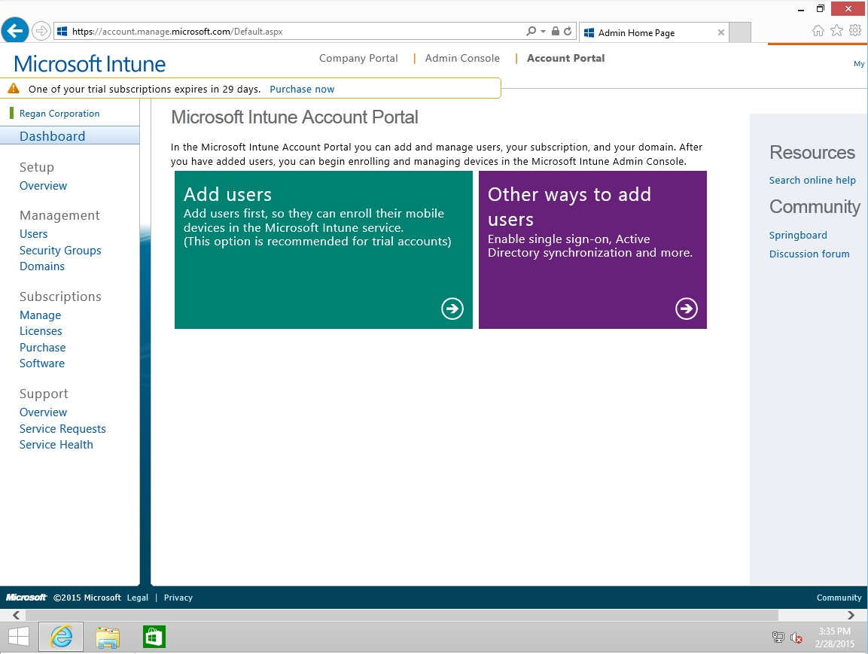
Figure 2-6. Viewing the Microsoft Intune Account Portal

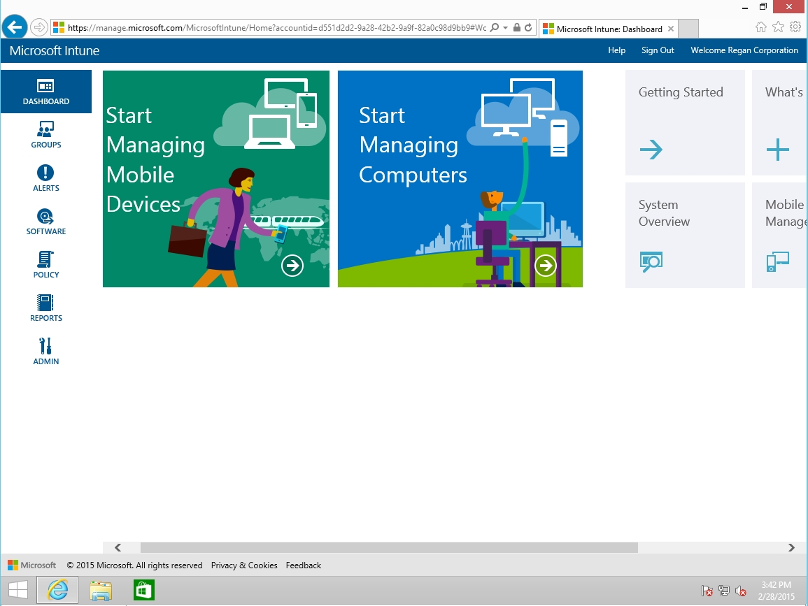
Figure 2-7. Viewing the Microsoft Intune Admin Console

After you subscribe to Microsoft Intune, you need to perform the following tasks:
- Configure a domain name.
- Add users and assign licenses for your subscription.
- Manage Microsoft Intune licenses for users.
- Assign administrative users.
- Configure Security Groups.
- Customize the Company Portal.
- Add devices to your subscription.

The domain name defines the account that users sign in with. To add a domain to the Microsoft Intune subscription, the domain is configured using the Microsoft Intune Account Portal.

Add and Verify a Domain
GET READY. To add and verify a domain, perform the following steps on a computer running Windows 10 with a connection to the Internet.
- On Win10A, log on using the contoso\administrator account and the Pa$$word password.
- On the Taskbar, click the Microsoft Edge icon to open Microsoft Edge.
- Open and logon to the Microsoft Intune Account Portal (https://account.manage.microsoft.com).
- Under Management click Domains.
- On the Domains page (as shown in Figure 2-8), click Add a domain.

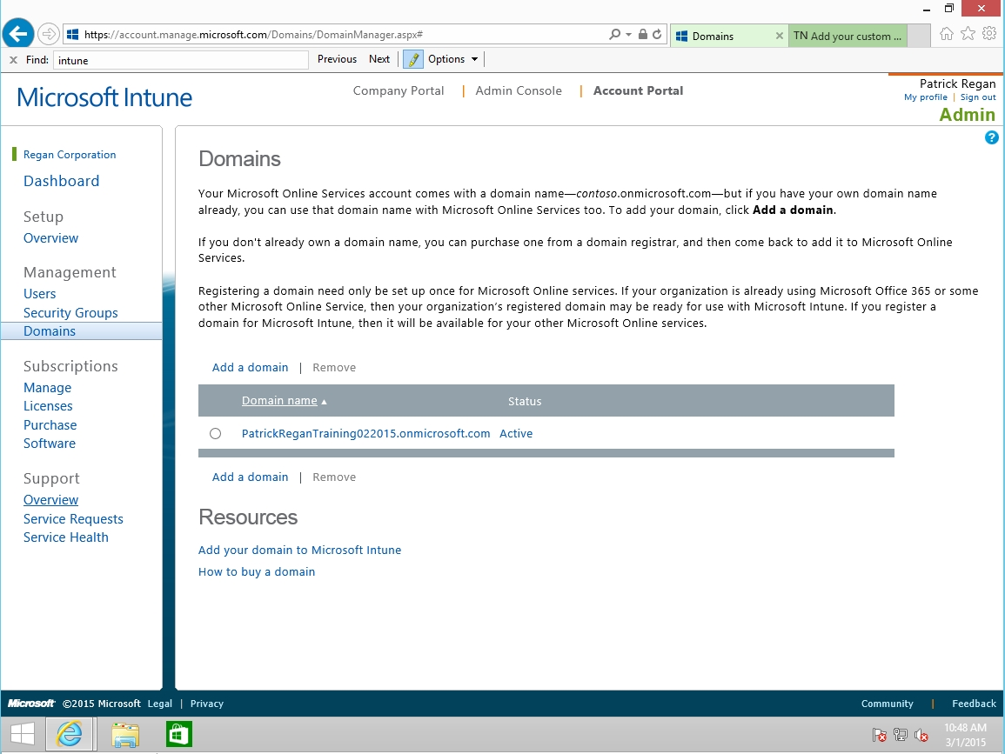
Figure 2-8. Managing domains

- On the Specify domain page, in the text box, type the domain that you want to add and then click Next.
- A common method to verify that you own a domain is to add a TXT record to the DNS zone for the domain. Therefore, after you add a TXT record to the zone, go back to the Verify domain page (as shown in Figure 2-9) and click the Verify button at the bottom of the page.

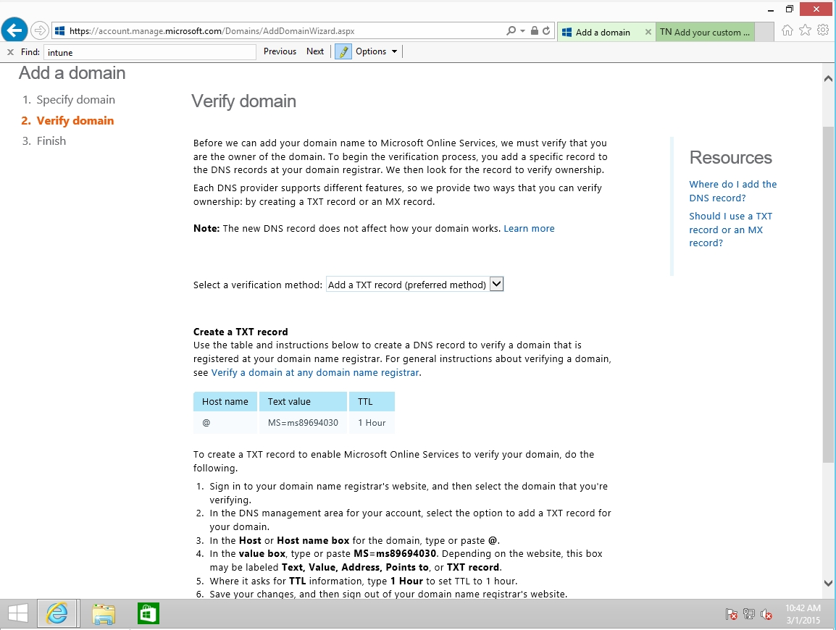
Figure 2-9. Verifying the domain

